Josh Business > Geochem Element Highlighter

I would like to make a tool that the user can select an element that they can nominate a threshold for or a % ppm that will give all the relevant points on a map within WA. With a view to include data taken from other countries.

Source data will be geochemical survey data and point map locations.

**Initial MVA source:**

<https://geochem.dmp.wa.gov.au/geochem/>

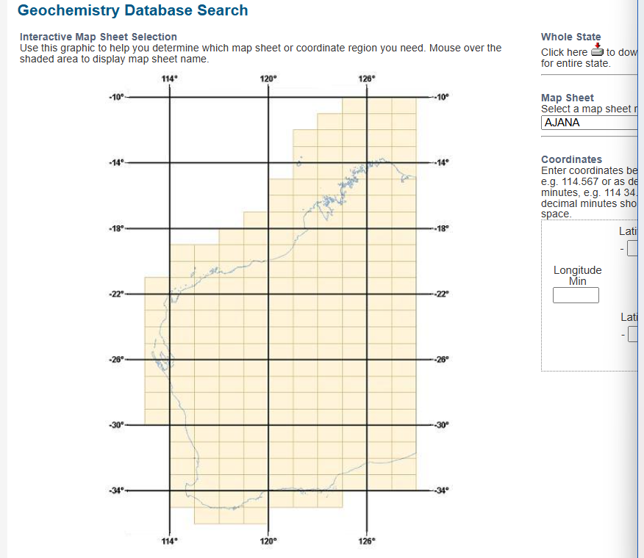

**Functional Requirements:**

Input percentage, ppm threshold or the most present base element in a survey and highlight that survey location on a map.

Results from exploratory analysis > Displaying copper dominant surveys:

